# User Guide

This guide helps you with understanding how to use Urgenda effectively as a task manager for your daily needs.

Table of Contents

User Guide 1

Getting Started 2

Feature Details 3

Add 3

Delete 3

Mark as Completed 4

Edit 4

Search 5

Exit 5

Advanced Features 6

Show more details 6

Archive 6

Undo/Redo 7

Block Multiple Timeslot 8

Prioritise 8

Shortcuts 8

Full list of all possible commands and command tags 9

# Getting Started

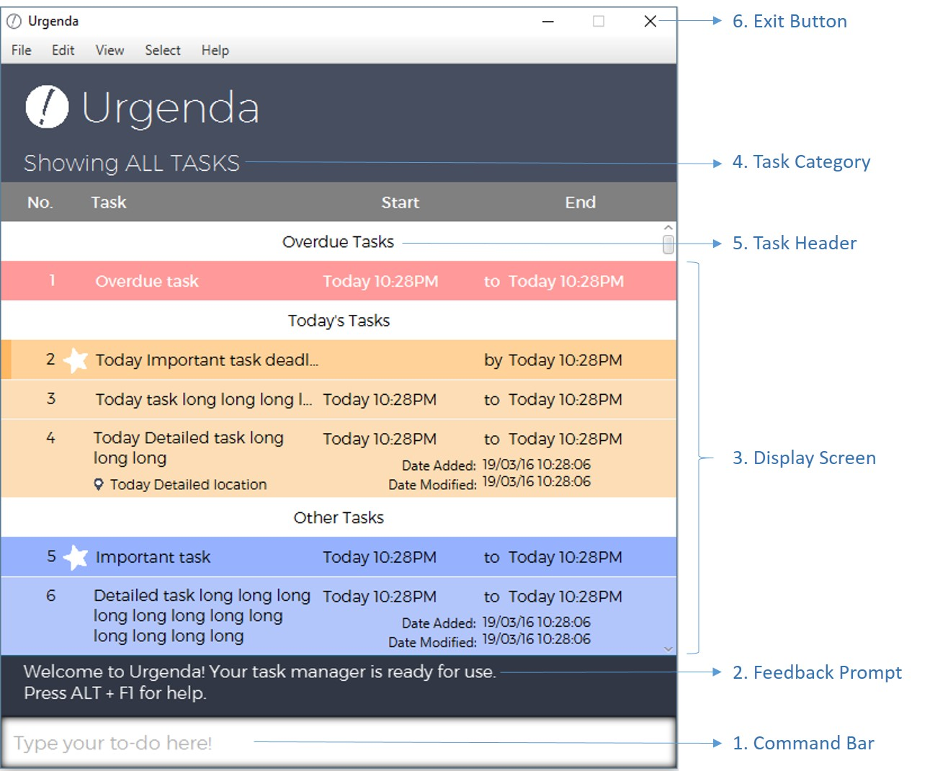

1. User input/command bar: Enter your to-dos here easily using the given Command Tags.
2. Feedback prompt: The outcome to any changes that you make to your tasks is shown here.
3. Display screen: Your tasks are categorised and displayed here according to time and priority by default.
4. Task category: This shows the type or category that the displayed tasks belong to (e.g. ALL TASKS, OVERDUE TASKS, #Assignment, etc.)
5. Task header: This indicates each sub-category for different tasks.
6. Exit button: Click to exit the program. Alternatively, type exit in the command bar to

exit.

# Feature Details

## Add

To create a new task, **Add** or **Create** are the command words, with the task name following thereafter, ie "Dinner with Mum"

Use **Command Tags** to add in details for the task, "**at**" for time, "**@**" for location, etc. For the **full list of Command Tags**, refer to Shortcuts

Tasks are separated into 3 categories, Events, Deadlines and Floatings.

* Event: Task is given with a start time and end time. Example: ***Add*** *Dinner with Mum* ***at*** *23/3/2016 7:00pm to 8:00pm*
  + If only a start time is given, then end time will automatically be set to 1 hour after the start time.
* Deadline: Task is given with only an end time. Example: ***Add*** *Return home* ***by*** *23/3/2016 7:00pm*
* 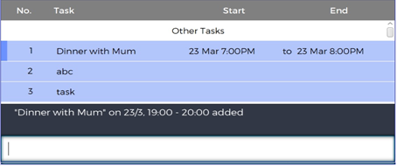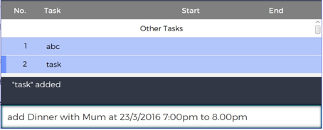Untimed (Floating): Task is given with no start time and end time. Example: ***Add*** *Dinner with Mum*

Figure 2: Added task is displayed on the window with the selector on it

Figure 1: Adding a task by typing into the command bar

## 

## Delete

To delete an existing task, **Delete**, **Del**, **Erase** or **Remove** are the command words that can be used to delete a task. Note that deleting a task *IS NOT* completing a task.

Specify the task number, the task description or simply highlight the task to be deleted.

Example:

* ***Delete*** *Dinner with Mum*
* 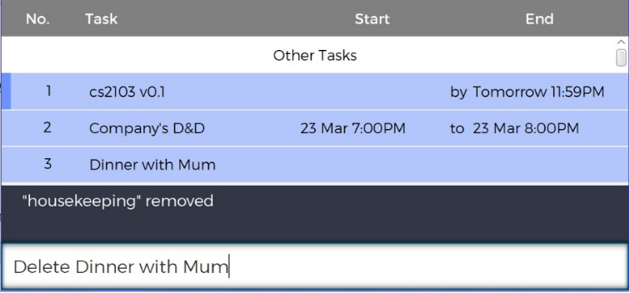***Delete*** *4*

Figure 4: Task is deleted and remove from display.

Figure 3: Deleting the task by typing the description into the command bar.

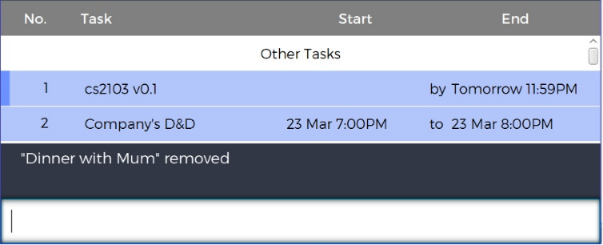

## Mark as Completed

To mark a task as done, **Done**, **Completed**, **Do**, **Mark**, **Finish**, **Fin** are the command words that can be used.

Similar to Delete, specify the task number, the task description or simply highlight the task to be marked as completed.

Example:

* ***Mark*** *Dinner with Mum*
* 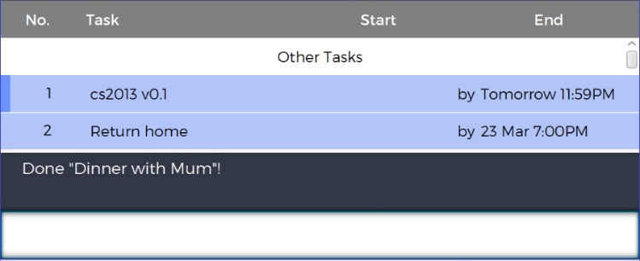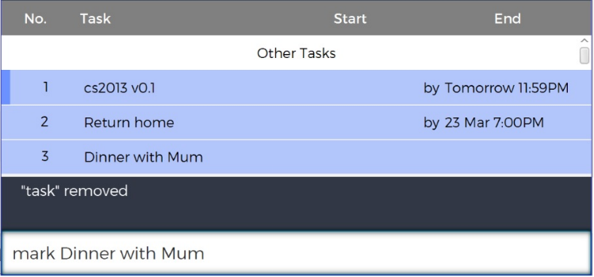***Done*** *3*

Figure 6: Task is marked as done, stored in archives and removed from display.

Figure 5: Marking the task by typing the description into the command bar.

## Edit

To edit an existing task, **Edit**, **Update**, **Change** and **Mod** are the commands that can be used.

Use **Command Tags** to change details for the task, "**at**" for time, "**@**" for location, etc. For the **full list of Command Tags**, refer to Shortcuts

If the task already has those details, then the new details will overwrite the old details.

Similar to Delete and Mark as completed, specify the task number, the task description or simply highlight the task to be edited.

Example:

* _**Change** Dinner with Mum **@** NEX
* 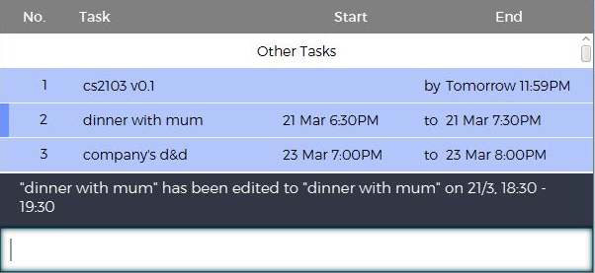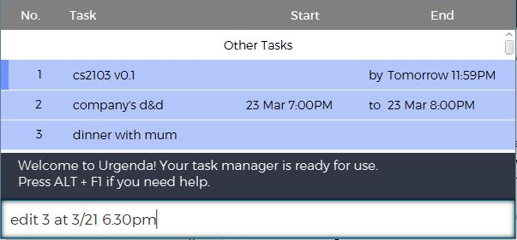_**Edit** 4 Dinner with Mum and Dad

Figure 8: Task no. 3 had time added to it, displayed accordingly in order of the timings.

Figure 7: Editing task no. 3 and adding time to it

## Search

To search for a word, **Search**, **Find**, **Show**, **View** or **List** are the commands that can be used.

**#** searches for the tags, and thereafter displaying the tasks.

* When searching for **#cow**, tasks with tags **#cows** and **#cowmilk** will also appear in the search result.

When searching for a date, all tasks with this particular date set as the deadline will be displayed. When searching for a word or phrase, all tasks that contain this particular work or phrase in their task description(s) will be displayed. When searching for time, time block with assigned tasks will be displayed.

Entering the search commands alone will simply show all existing tasks.

Example: ***Search*** *boss*

* *Report to boss by 4/4/2016 3:00pm*
* *Meeting with boss at 6/4/2016 2:00pm to 5:00pm*

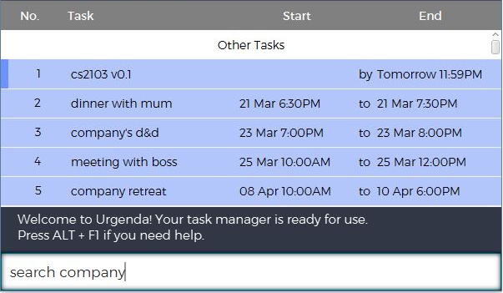

Figure 9: Searching for tasks with the word “company” from among all the tasks

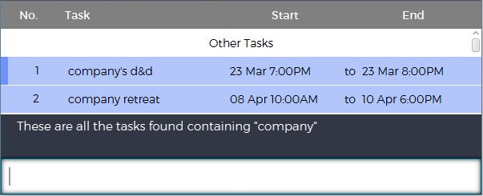

Figure 10: Tasks that contains the word “company” is displayed for the user.

## Exit

To exit Urgenda, click the top right exit button, or type **exit**

# Advanced Features

## Show more details

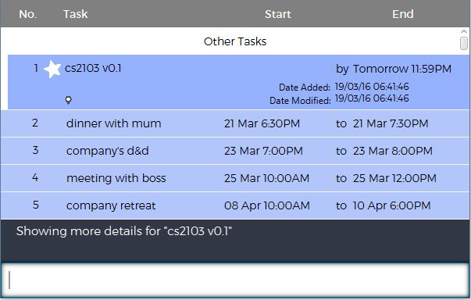**Showmore** is a specific command to expand a specific task for the user to view more details about that task, such as the location, the tags for that task, or for any other additional details.

Figure 12: More details shown for the first task.

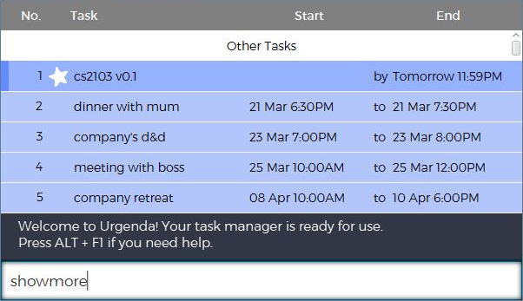

Figure 11: Requesting for more details to be shown for the task no. 1, where the selector is at.

## Archive

To show previously completed tasks, the commands are **Archive** and **Showarchive**

## Undo/Redo

* **Undo** and **Redo** are classic features, allowing you to undo the previous action taken. This will result in any changes made to certain task(s) being restored. A maximum of 10 consecutive actions are possible for both **undo** and **redo**. For example:
  1. ***delete*** *Dinner with Mom* (Task with Dinner with Mom is deleted)
  2. ***undo*** (Task Dinner with Mom is restored with all its previous details)
* However, when undo is implemented at least once, any new commands (other than **undo** and **redo**) will discard all saved redo actions after the new action has been implemented. For example:
  1. ***delete*** *Fix lightbulb* (Task “fix lightbulb” is deleted)
  2. ***undo*** (Task “fix lightbulb” is restored)
  3. ***add*** *Meeting with boss* (Task “Meeting with boss” is added)
  4. 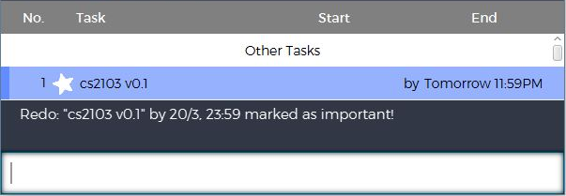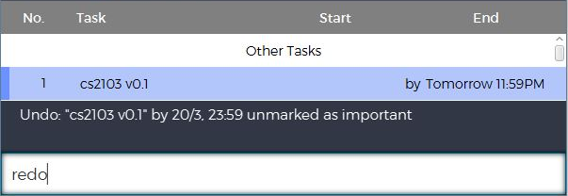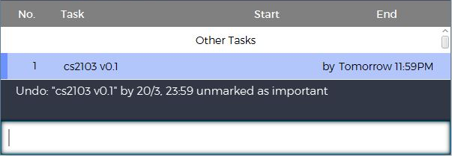***redo*** (No tasks to redo, previously undone actions are cleared.)

Figure 16: Task no. 1 is returned to its original state of being marked as important.

Figure 14: Task no. 1 is returned to its previous state of not being marked as important.

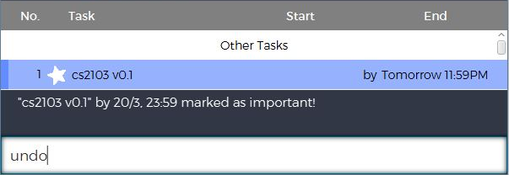

Figure 15: Command for redo is given to re-mark task no. 1 as important.

Figure 13: Previously, task no.1 is marked as important. Command for undo is given

## Block Multiple Timeslot

## Prioritise

This feature allows you to mark certain tasks as important. These tasks will be displayed with a logo next to the task.

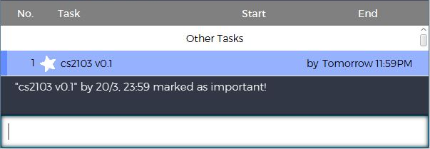**Urgent**, **Important**, **Impt**, **Pri** or **Pin** are the commands to prioritise a task. Example:

Figure 18: Task no. 1 is displayed with the star to show as important

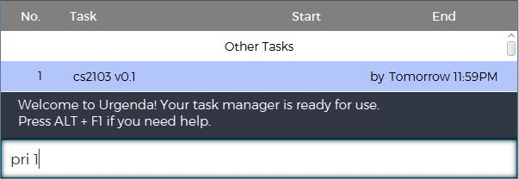

Figure 17: Command to mark task no. 1 is as given.

# Shortcuts

* Ctrl + Z / Ctrl + Y : Undoing/Redoing what was previously written in the command bar
* Ctrl + D : Displays that default view of showing all tasks
* ▲: Cycle through previous commands from command history
* ▼: Cycle through next commands from command history
* Ctrl + ▲ , Ctrl + ▼ : Changes the highlighted task on graphical display
* Alt + F4 : Exits Urgenda
* Ctrl + Alt + D : Quick launch of Urgenda

# Full list of all possible commands and command tags

|  |  |  |  |
| --- | --- | --- | --- |
| **Action** | **Command Words to be used** | | **Command Tags to be used**  If the tags have an * before it, they are optional. |
| Creating a new task | • Add, Create | | * Task Description * *Time: **at** * *Location: **@** * *Date: **tomorrow, today, DD/MM, DD Month, next week/day** * *Tag: **#** |
| Deleting a task | • Delete, del, erase, remove | | * Task Description * Task Number |
| Completing a task | • Done, Completed, Mark, Finish, Fin | | * Task Description * Task Number |
| Editing a task | • Edit, Update, Change, Mod | | * Task Description * Task Number • *Time: **at** * *Location: **@** * *Date: **tomorrow, today, DD/MM, DD Month, next week/day** * *Tag: **#** |
| Searching for a task | • Search, Find, Show, View, List, # | | * *Task Description * *Time: **at** * *Location: **@** * *Date: **tomorrow, today, DD/MM, DD Month, next week/day** * *Tag: **#** |
| Exiting the program | • Exit | |  |
| Show details | • Showmore | | * Task Description * Task Number |
| Accessing archives | • Archive, Showarchive | |  |
| Undo/Redo an action | • Undo, Redo | |  |
| Prioritisation | • Urgent, Important, Pri, Impt, Pin | | * Task Description * Task Number |
| Adding multiple timeslots | • | Block, Alloc, Reserve | * Task Description *Time: **at** |
|  |  |  | * *Location: **@** |
|  |  |  | * *Date: **tomorrow, today, DD/MM, DD Month, next week/day** |
|  |  |  | * *Tag: **#** |
|  |  |  | * Additional timeslots: **,** |
| Releasing multiple timeslots | • | Release, Unblock | * Task Description * Task Number * At least 1 timeslot |